LCC Prize Giving 2018/2019



**LCC Prize Giving 2019/2020**

**Lanark Golf Club**

**20th March 2020 7 PM for 7.30 PM**

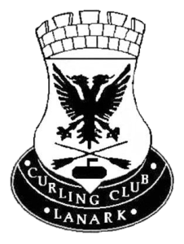

New Lanark Mill Hotel

29th March 2019 7.00 PM for 7.30 PM

**Dinner Menu & Order**

**Starter**

Duo of Fanned Melon, Fresh Berries & Orange Sorbet

Tomato & Roast Red Pepper Soup-Rich Warm soup topped with Homemade Pesto & Grated Parmesan

Smoked Salmon Roulade – Smoked Salmon wrapped around Salmon Pate, Baby Leaves and Lemon & Chili Dressing

**Main**

Pan Seared Chicken – Pan Seared Stuffed Chicken with Rosemary & Garlic Mouse, Pancetta potato Grain & Thyme Jus

Grilled Seabass – Grilled Seabass, Lemon & Chive Sauce, Bubble & Squeak Potato Cake

Farmhouse Beef Casserole – Slow Cooked Scottish Beef with Root Vegetables Topped with Country Style Dumpling‘s with a Cream Chive Mash

**Dessert**

Baileys Cheesecake – Cheesecake, Sweet Berry Compote & Tasted Nuts

Cappuccino Crème Brule – Crème Brule with Main Shortbread

Rhubard Crumble Tart – Individual Tart, Equis Honeycomb Ice Cream & Chocolate Shards

Tea & Coffee

Please advise if you have any dietary requirements.

Could you please complete below and return to me by the 3rd March 2019.

**I/we wish to attend Yes/ No**  **My choice of menu is:**

**Club Members Name** **Spouse/Partner**

Starter Starter

Main Main

Dessert Dessert

**Cost: 3 Course £21, 2 Course £18**

**Thanks, Hugh Campbell – President Email hbc1951@hotmail.co.uk**